
www.annagravelle.com
studio@annagravelle.com
07930 374006

WAVEFORM SOUND ABSORBER PANELS
A collaboration between RPG Europe and Anna Gravelle

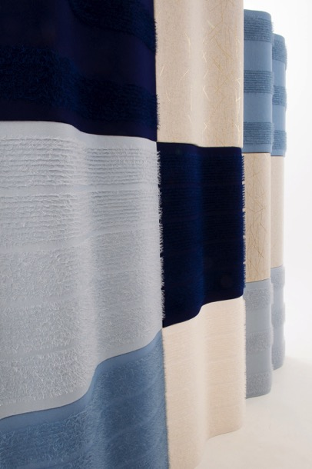

©Anna Gravelle

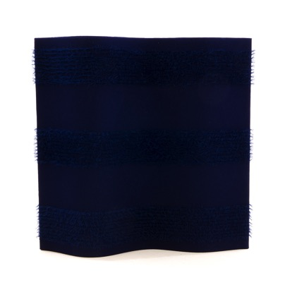
Tufted wool French Navy 3 bands

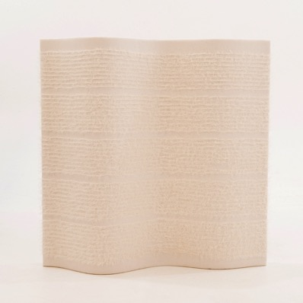
Tufted wool Cream 5 bands

©Anna Gravelle

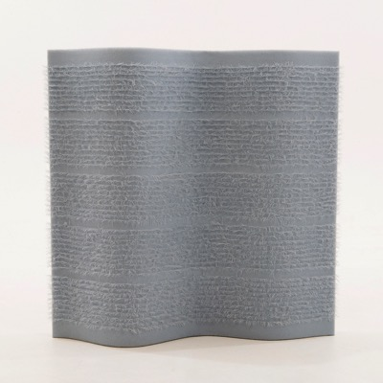
Tufted wool Pebble Grey 5 bands
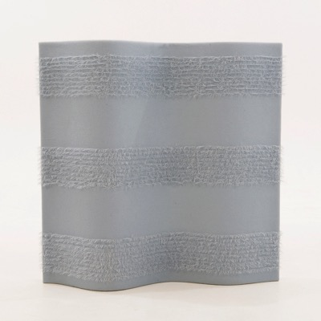
Tufted wool Pebble Grey 3 bands

©Anna Gravelle

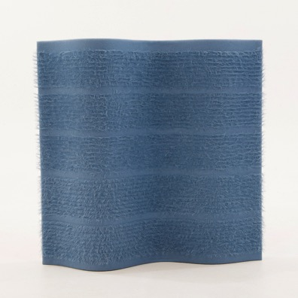
Tufted wool Storm Blue 5 bands
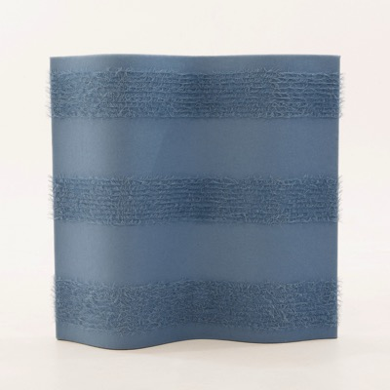
Tufted wool Storm Blue 3 bands

©Anna Gravelle

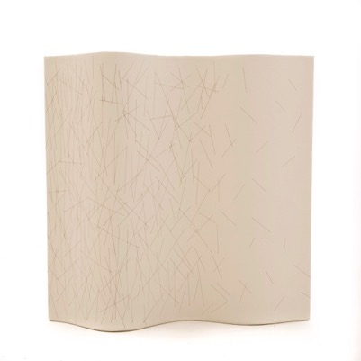
Laser etched cream leather
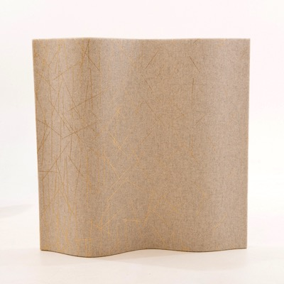
Gold foil screen print on Porcelain wool melange

©Anna Gravelle

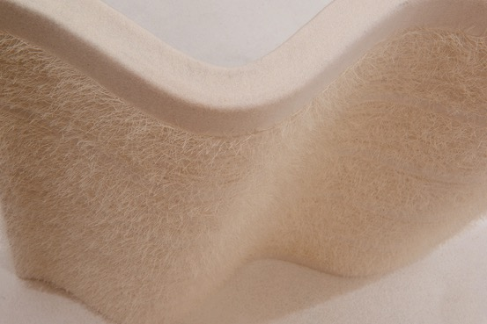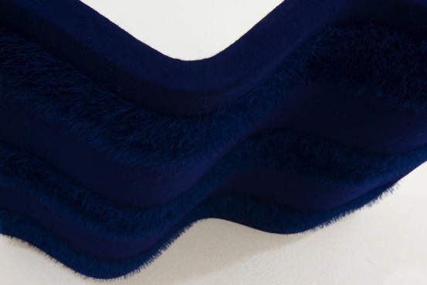

©Anna Gravelle

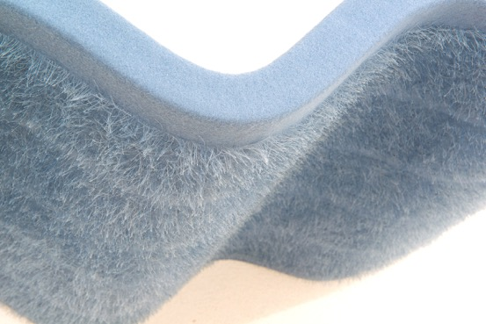
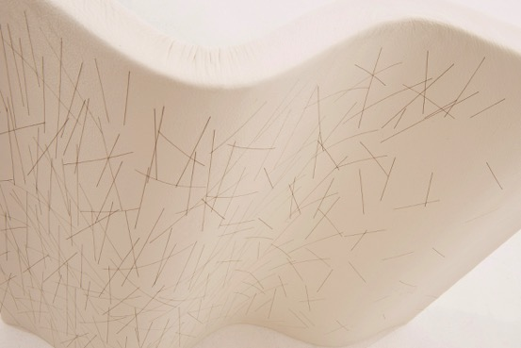

©Anna Gravelle

INTERIOR UPHOLSTERY ACCESSORIES
We can supply bespoke fabric solutions

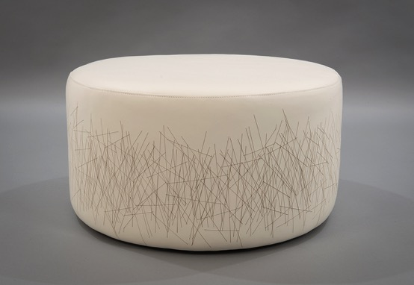
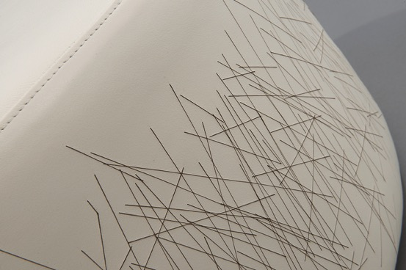
Laser etched Italian leather

©Anna Gravelle

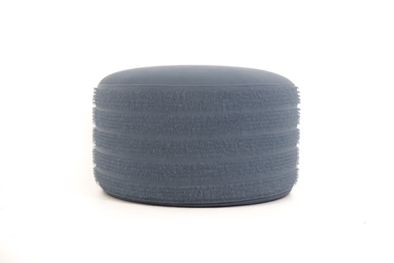

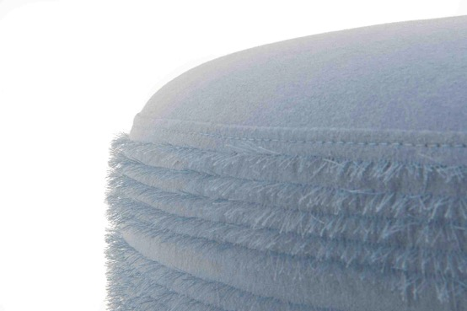
Tufted wool Storm Blue

©Anna Gravelle

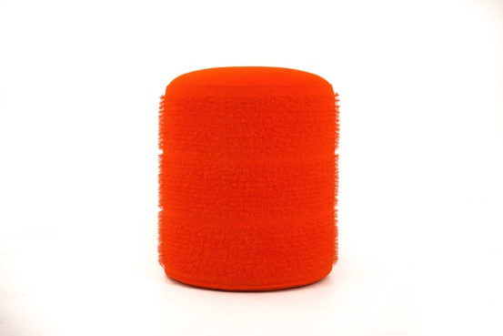

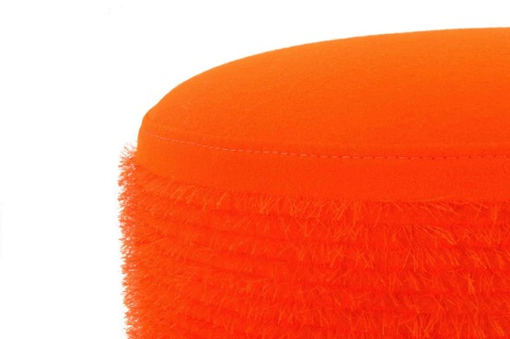
Tufted wool Orange

©Anna Gravelle

MULTICOLOURED STITCH DIGITAL PRINT [VELVET, LINEN, COTTON]

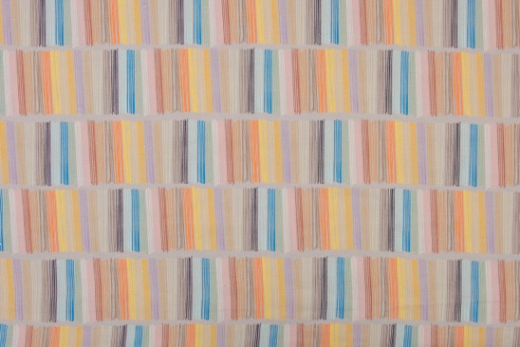

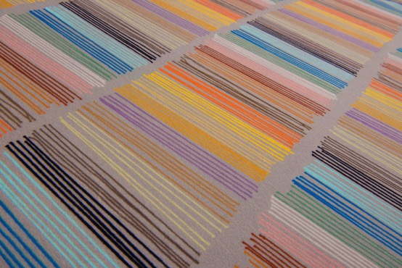

STITCH & PUFF SCREENPRINT [WOOL]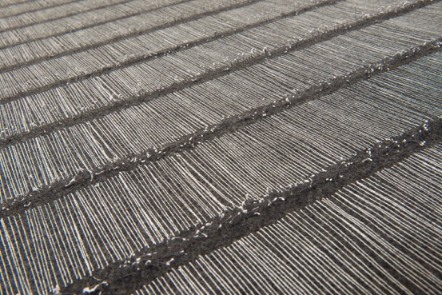

CROSS-HATCH & TUFT SCREENPRINT [WOOL]

